
Company
Logotype

Cone Beam Computed Tomography- Report



Porur Dental X-rays & CBCT

Patient Name : Baby. Madhuja Chakravarthy | Date of Report : 27.06.2024
Age/ Gender : 12 years/ Female | Region of Interest : CBCT Maxilla
Referring doctor: Dr. Suchitra Mohan | Indication : Impacted teeth
Clinical Notes: Nil
PATIENT INFORMATION

CBCT Maxilla provided
CBCT – IMAGE DETAILS

RADIOGRAPHIC INTERPRETATION

- Deciduous teeth present in the anterior maxillary region: 53, 54, 55, 64, 65.
- The tooth 13 appears to be within the alveolar bone, distally tipped with its crown near the radicular portion of 12, 53 and root of 13 in proximity to the medial wall of right maxillary sinus and floor of nasal cavity.
- The tooth 23 appears to be horizontally impacted, with its crown facing anteriorly, near the anterior surface of maxilla and the radicular portion of 23, appears to involve the floor of nasal cavity and the medial wall of left maxillary sinus. The crown of 23 appears to cause discontinuity of the anterior surface of maxilla at the level of lateral nasal region.
- The tooth 23 is positioned such that it involves the palatal cortical bone.
- The tooth 24 is positioned such that the edentulous space for eruption of 23 is compromised.
- Distance between the alveolar ridge and 23: 9.62 mm
- Permanent successors in relation to 54, 64 present.

RADIOGRAPHIC IMPRESSION


- Impacted tooth: 23.
- Erupting tooth: 13.

IMAGES FOR REFERENCE

PANORAMA VIEW

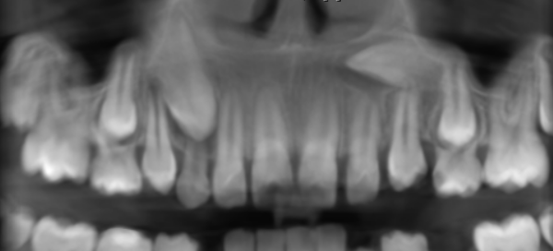

3-DIMENSIONAL VIEW

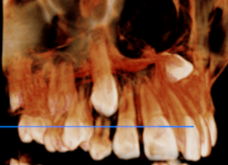
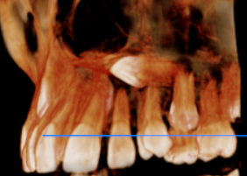
13 REGION | 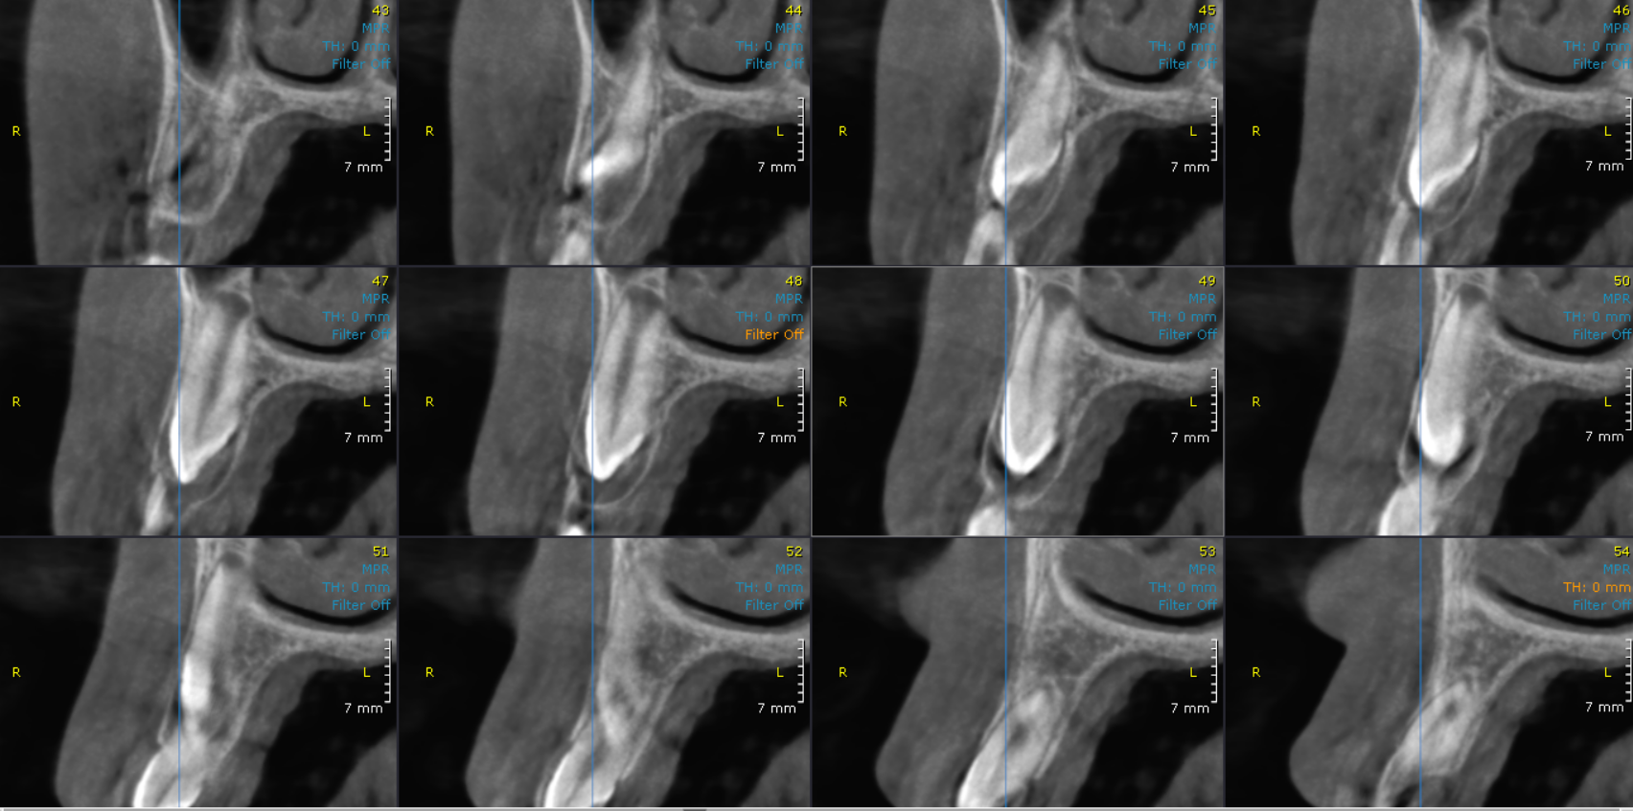
23 REGION | 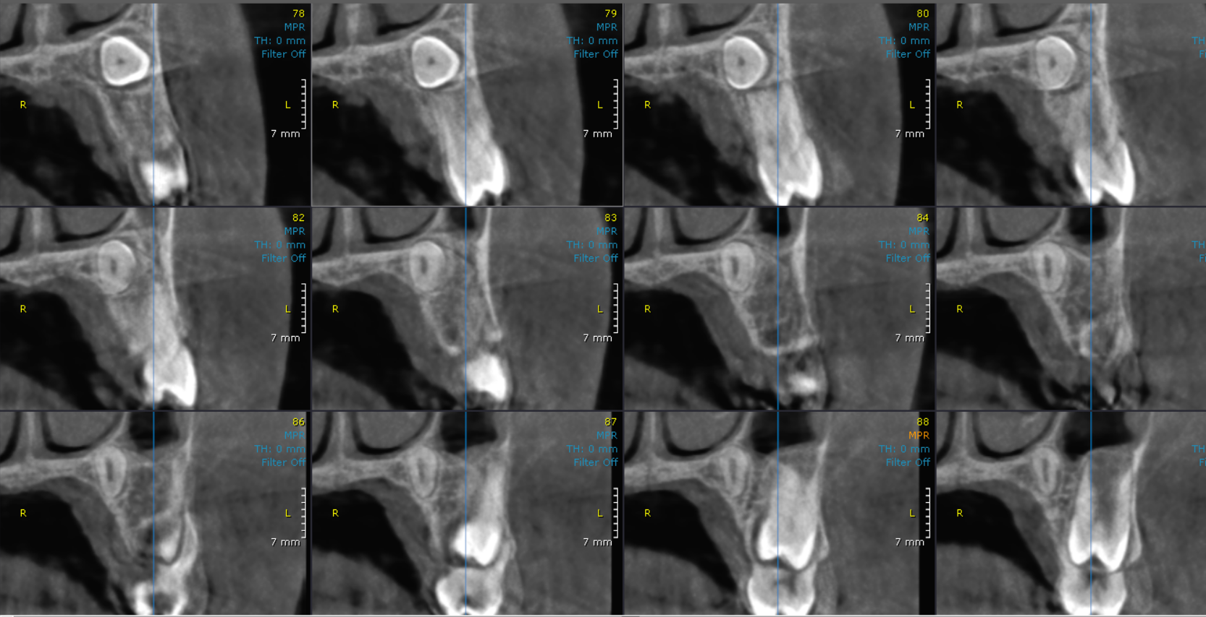
CROSS- SECTIONAL IMAGES

**** End of report ****

